Pacific Public Health Surveillance Network Update
INFORMATION DOCUMENT
1. BACKGROUND
The Pacific Public Health Surveillance Network (PPHSN), jointly created by the Pacific Community (SPC) and the World Health Organization (WHO) in 1996, is a voluntary network of countries and organizations dedicated to the promotion of public health surveillance and appropriate response to the health challenges of the region in order to improve the health of Pacific Island people. The core members of the PPHSN are the Departments and Ministries of Health of the Pacific Island countries and territories (PICTs); the allied members of the PPHSN comprise regional training institutions, agencies, laboratories, and other organizations or networks with an interest in public health surveillance in the region that chose to be a PPHSN member. PPHSN has five development strategies: (1) Harmonisation of surveillance data and development of appropriate surveillance systems (with priority given to outbreak surveillance and response); (2) Publication/dissemination of timely, accurate and relevant information, in various forms; (3) Training in applied epidemiology and public health surveillance, adapted to regional needs; (4) Extension of the electronic communication network to new partners, new services and other public health networks (telehealth); and (5) Development of relevant and cost-effective computer applications.
The PPHSN Coordinating Body provides oversight over the PPHSN through its annual meeting. PPHSN decisions, actions and recommendations are presented and discussed at the Heads of Health meeting annually.
PPHSN has six service networks which corresponds to the technical stages of outbreak-prone disease control, in particular, and health emergencies, in general.
Pacific Syndromic Surveillance System was set-up in 2010 for surveillance of priority syndromes reported by sentinel sites located in each PICT. The system was designed for early outbreak detection of the most common epidemic-prone diseases occurring in the Pacific.
Operational since 1997, PacNet, the service network of PPHSN for alert and communication, allows rapid sharing and transmission of relevant health information and alerts enabling PICTs to prepare, especially for epidemics.
Established in 2000 for confirmation and identification of disease causal agents, LabNet, a 3-tier network of public health laboratories, allows all PICTs access to high quality diagnostic services that are not available in country.
The EpiNet response network was set up in 2001. It is a network of national and territorial multi-disciplinary teams whose members are selected by each PICTs. EpiNet teams are responsible for outbreak and health emergency preparedness and response in the field.
The Pacific Infection Control Network or PICNet was launched in 2006 to standardise surveillance and response systems for infections that spread in health care facilities.
Strengthening Health Interventions in the Pacific (SHIP) – Data for Decision Making (DDM) programme was established in 2014. A 3-tier capacity development programme, SHIP builds on the principle ‘from work, at work, for work’, and incorporates already existing initiatives for capacity building in essential public health functions.
2. ACTIONS TAKEN
A. Update on action taken:
A1. PPHSN Review: Twenty two years after the establishment of PPHSN, a lot has happened and work undertaken towards the attainment of its goal and objectives. Emerging public health risks such as unprecedented waves of arboviral disease outbreaks, antimicrobial resistance, zoonoses and those brought about by climate change, such as increasing intensity of natural disasters and post-disaster health risks call for new approaches to dealing with such situations. In April 2019, SPC as Focal Point of the PPHSN-CB advised of an external review of PPHSN and its services to determine the impact of the PPHSN services and strategies on the health information system, public health surveillance and outbreak response in the Pacific at both the country and regional levels. Additionally PPHSN’s contribution to regional health security and achievement of International Health Regulations (2005) (IHR (2005)) core capacities at country level will be evaluated. The evaluation results are intended to guide the updating of the PPHSN strategic plan for the coming years.
A2. PPHSN Structure and Governance: In April 2019, the Pacific Heads of Health were informed that the annual meeting of the PPHSN will continue but will become a meeting of the Directors of Public Health rather than the current level of representation to ensure a strong forum for strategic thinking on public health issues. The PHOH further noted that the Directors of Public Health meeting will be held back-to-back with PHOH every second year, alternating with the meeting of Directors of Clinical Services.
A3. PSSS: From 2014-2018, 20 PICTs have contributed weekly data to the PSSS (Annex 1). In this time, there have been over 21,800 notifications of acute fever and rash with the last outbreak of measles occurring in the Pacific in 2014, over 215,000 cases of diarrhoeal syndrome, over 512,000 cases of influenza-like illness, 47,526 of prolonged fever (a proxy for typhoid fever and leptospirosis), and nearly 32,180 notification of dengue-like illness. The system has identified a number of regionally important outbreaks, including measles, dengue, chikungunya and Zika virus, laboratory-confirmed influenza and leptospirosis. PSSS was evaluated in 2011 and 2015.
A4. PacNet: There were 126 new PacNet subscribers in 2018 (19% increase from 2016), for a cumulative 1,091 subscribers since the inception of PacNet. 69% are from PICTs; 12% from Australia, 7% from USA, and 6% from New Zealand. More than 8,700 alerts and reports on epidemics and emerging diseases were shared through PacNet. There was a 91% change (35% in 2016 vs 67% in 2018) in the number of PICTs experiencing outbreaks posting reports on PacNet between 2016 and 2018.
A5. LabNet: Laboratory technical assistance and Laboratory Quality Management System (LQMS) assessments done for the period 2015 to 2018 highlighted varying levels of quality management and service development (Annex 2). Currently only 5 of 29 PICT laboratories are on track to achieve international accreditation by end 2020. This was an Asia-Pacific strategy defined by WHO in 2010-2015 that remains under-achieved and well overdue in 2019. The laboratories of Tonga, Vanuatu, Samoa, Cook Islands, Nauru are close and leading the drive towards full international Laboratory compliance (ISO15189).
SPC signed a memorandum of understanding with four level 2 Pacific reference laboratories. The MOU defined how the level 2 reference laboratories will collectively cooperate and support SPC and PPHSN in strengthening laboratory capacity in the Pacific region (Annex 3).
A6. EpiNet: Twenty five national and territorial EpiNet teams exist, with nationally selected focal points in five categories. An additional category (i.e. disaster management) was proposed for inclusion during the 2019 PPHSN-CB meeting.
A7. PICNet: As a critical step in infection control, a regional guideline on infection prevention and control is in the process of being updated. Support was provided to 3 PICTs to update their national infection prevention and control guideline, with accompanying training on donning and doffing of personal protective equipment.
A8. SHIP-DDM: In January 2019, Fiji National University has provided academic accreditation to the 3-tier SHIP programme. Implementation of SHIP-DDM is through the PPHSN core and allied members. As of end of 2018, 249 health officers from 17 PICTs have completed at least one of the 5 modules of the PGCFE course. Eight were officially conferred graduates of PGCFE in 2016. With financial support from donors and funders, implementation of PGCFE was ramped up since 2017. Forty six percent (115/249) have completed all 5 modules and are eligible to graduate from the PGCFE course at the end of the year 2019 pending provision of required university documents. Health officers attending the DDM/PGCFE course also implement system improvement projects identified as priorities by the health authorities. Following recommendations from the PHOH in a meeting in 2018, FNU accorded flexibility in the implementation of PGCFE.
B. Implementation challenges:
B1. Pacific Syndromic Surveillance System: In 2017, PSSS moved to an electronic EWARS platform for real-time data visualisation. In addition Fiji, Tonga, Solomon Islands and Vanuatu are using the EWARS platform for their National Syndromic Surveillance System. The PPHSN-CB has discussed the need to review the list of syndromes and case definitions to keep pace with emerging diseases and strengthened surveillance capacity in the Pacific. The regional PPHSN meeting in June 2019 agreed to expand PPHSN’s surveillance support from only syndrome surveillance to include event-based surveillance, hospital-based surveillance, AMR surveillance, laboratory-based surveillance, notifiable disease surveillance, vector surveillance and the alert map.
B2. PacNet: While an increase in the number of PacNet subscribers and a significant percentage change in the number of PICTs having outbreaks sharing their reports on PacNet were noted, PICTs continue to face challenges in data quality and timeliness of sharing outbreak reports. Data quality and timeliness of sharing outbreak reports affects the ability of both national authorities and regional technical assistance providers to respond rapidly and implement control measures. Australia, Hawaii (USA) and New Zealand provide useful alerts when they identify imported cases of outbreak-prone diseases from PICTs. Surveillance information from PICTs is also useful to these countries. More collaboration will improve this mutually beneficial report sharing. Awareness of outbreaks within neighbours in the region is a critical part of risk assessment and preparedness for PICTs. Maintaining an accurate picture of current risk depends upon timely sharing of notices of new outbreaks to PacNet and timely declaration when outbreaks are over.
B3. LabNet: Laboratory Quality Management System (LQMS) training and assessments are meant to improve service delivery while strengthening the laboratory system. Implementing LQMS assessment recommendations to address identified gaps and limitations in laboratory practice for lasting system improvement without dedicated staff is challenging. Sufficient funding and expertise on International Air Transport Association (IATA) certified shippers training to meet international regulations should be maintained. Laboratories operating in the Pacific region are only partially achieving their goals in quality management and service development. The region is slow to achieve the international accreditation goals of performance and quality defined in the WHO Asia Pacific strategy of 2010-2015 and remains under achieved in this area projecting to 2020. A shortage of clinical Pathologists, qualified scientists and under resourced services continues to hinder the standards of practice and credibility of our diagnostic laboratory services.
B4. EpiNet: Rapid and immediate response is key to outbreak control. Having a strong cadre of focal points for various sectors relevant for outbreak response and control to aggregate, triangulate, analyse and act on the data and information available is not sufficient. Periodically updating and sharing the registry of focal points to others in the country and in the Pacific region who have stakes in disease surveillance and response are useful for regional coordination.
B5. PICNet: Resources and expertise in infection prevention and control in most of the PICTs is minimal. In most countries, infection control guidelines, policy directives, sufficient infrastructure and health officers who will be responsible for implementing and monitoring infection prevention and control programmes are lacking.
B6. SHIP-DDM: Funding for implementation of PGCFE is largely reliant on external sources. SHIP-DDM should continue to adapt so that it addresses the priority problems, day-to-day work flows, health information system and HR development needs of the PICTs. For the SHIP programme to be relevant, reaching the right target audience and ramping up delivery of the course to penetrate health agencies across the Pacific region should be ensured. Ultimately, health officers completing the course and having acquired the desired competencies should be retained for service in the country. National role delineation mechanisms and career structures should continue to evolve to keep up with the new skills and qualifications acquired by course graduates.
C. Future directions:
C1. Strategic directions and priorities of PPHSN: While the challenges and priorities of the island countries and territories across the Pacific differ in their form, funding basis and interactions with national and regional entities, the support service networks of PPHSN remain steadfast and will continue to evolve to adapt to national and regional challenges and priorities. The PPHSN strategic plan will be updated following completion of the PPHSN external review.
C2. Enhancing surveillance data analysis and reporting: The list of syndromes and case definitions used for syndromic surveillance will be updated to keep pace with emerging diseases and to strengthen early detection of outbreak in the Pacific. We will expand syndrome surveillance to include Severe Acute Respiratory Illness (SARI) and expand support to enhancing event-based surveillance, hospital-based surveillance, AMR surveillance, laboratory-based surveillance, notifiable disease surveillance, vector surveillance and the alert map.
C3. Providing timely alert and communication: To provide timely alert and facilitate effective response, surveillance activities need to have coordinated arrangements for risk assessment and early warning. We will incorporate the emerging disease alert and outbreak mapping into the syndromic surveillance system, together with other surveillance systems recommended for use by the delegates to the 2019 Regional PPHSN meeting, to add value to country-level surveillance reports.
C4. Strengthening laboratory capacity: A roadmap for laboratory accreditation is being reviewed. We have initiated activities to set regional benchmarks for laboratory quality and qualification standards, including the benchmarks for the number of pathologists required to support improved laboratory services in PICTs and number of accredited laboratories required in the region, and explore creation of affordable mechanisms for lab accreditation for PICTs.
C5. Responding to emerging threats: With financial assistance from the French Development Agency (Agence Francaise de Developpement), a Pacific-specific manual for Aedes mosquito surveillance and control is being written. Entomology training for technical officers and vector control programme managers will be conducted. Support to PICTs to align existing national infection prevention and control guidelines to the regional guideline will be provided (Annex 4). Training on microbiology will be conducted for 6 PICTs in 2019 (Annex 4).
C6. Translating capacity development into improved public health systems: A number of training cohorts and system improvement projects are underway. In addition to the sub-regional cohorts which will continue this year, new cohorts of the PGCFE courses will be initiated in 7 countries in the South Pacific in 2019. Training manual for trainers and trainees is in the process of development, with plans to commission French translation of the PGCFE course to enable delivery in Francophone countries in 2020-2021. The first cohort for the next stage of SHIP at the Postgraduate Diploma level will be conducted in 2020 (Annex 5).
3. CONCLUSIONS
PPHSN is adapting and will continue to adapt to reflect and respond to the modern public health threats in the Pacific region. Expansion of PPHSN’s surveillance support to include other surveillance systems will strengthen surveillance capacity in the Pacific as it keep pace with emerging and re-emerging infections. The slow uptake of laboratory facilities in the Pacific region to achieve the international accreditation goals of performance and quality management require financial investment and commitments from governments if laboratory accreditation is to become a reality. The capacity development program SHIP developed in response to the call from the Pacific Health Ministers is a good tool to enhance core competencies required for data management to support health departments to respond more effectively to the high prevalence of non-communicable diseases, to endemic and emerging communicable diseases and to the accelerating effects of climate change on health. The program is also a mechanism to strengthen health systems to accelerate progress towards achieving the Pacific vision of Healthy Islands.
We invite the Pacific Health Ministers to:
- Ensure that national focal points take part in the consultations to be conducted as part of the PPHSN review.
- Ensure that health agencies report suspected outbreaks to WHO, SPC and CDC as early as possible, and formally declare an end to all outbreaks using agreed-on criteria to timelines.
- Ensure that health agencies share stories and documents related to surveillance and response activities with the PPHSN-CB Focal Point for uploading to the new PPHSN website.
- Support the expansion and funding of the World Mosquito Programme beyond the four PICTs currently covered.
- Adopt the recommendation of the 2019 Regional PPHSN meeting to expand surveillance support to include syndrome surveillance as well as event-based surveillance, hospital-based surveillance, anti-microbial resistance surveillance, laboratory-based surveillance, notifiable disease surveillance, vector surveillance and the alert map.
- Adopt the recommendation of the 2019 Regional PPHSN meeting for countries to report case fatality rates due to confirmed cases of influenza and dengue.
- Support the development of national anti-microbial resistance plans and updating of the national infection prevention and control policies.
- Support activities for strengthening laboratory service capacity to lift laboratory standards across the region, and endorse development by PPHSN of a laboratory accreditation system that is affordable and appropriate to the needs and conditions in PICTs.
- Ensure that national focal points update/review their inventories of laboratory chemicals and protocols for meeting health and safety requirements for chemical use.
- Identify in-country mentors for SHIP-DDM and allow time during work hours for health officers attending training to complete course requirements and projects.

Annex 1. Pacific Syndromic Surveillance System notification, 2014-2018. Data from 20 PICTs
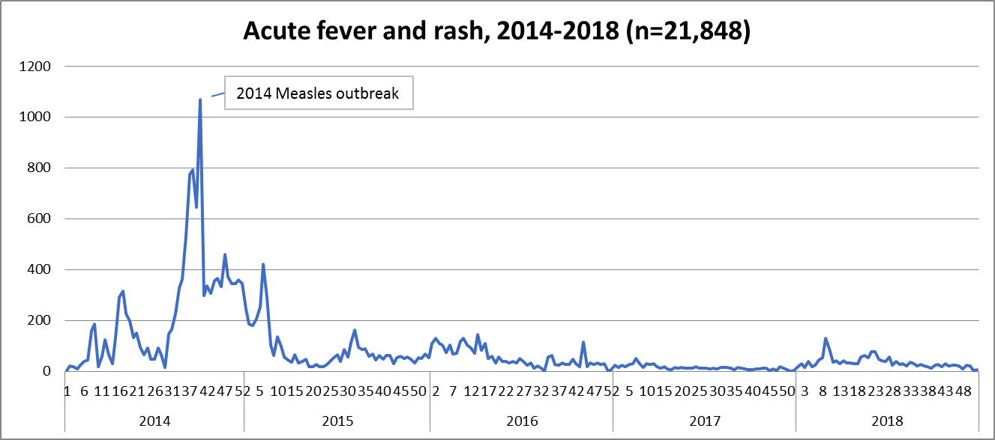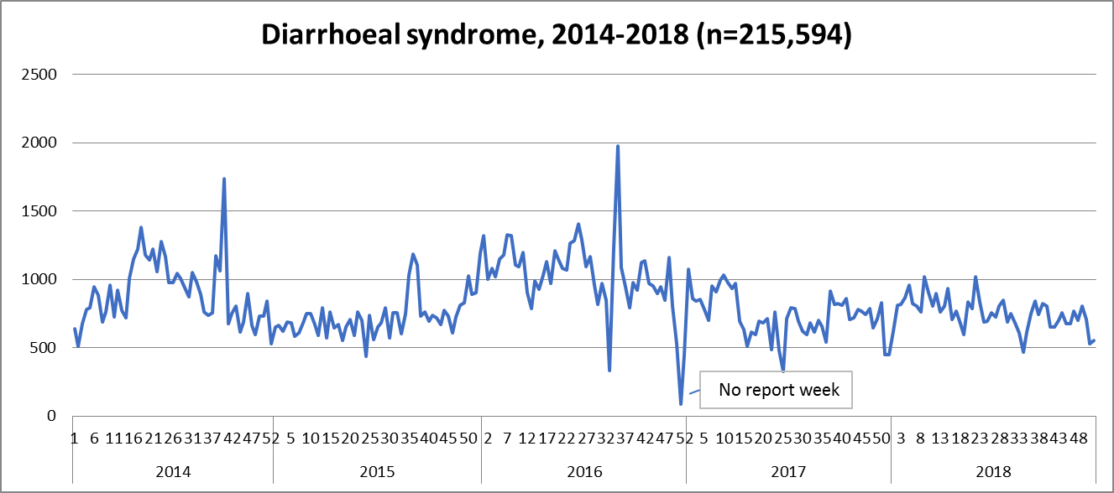
Rotavirus
Rotavirus
Dengue
Chikungunya and Zika
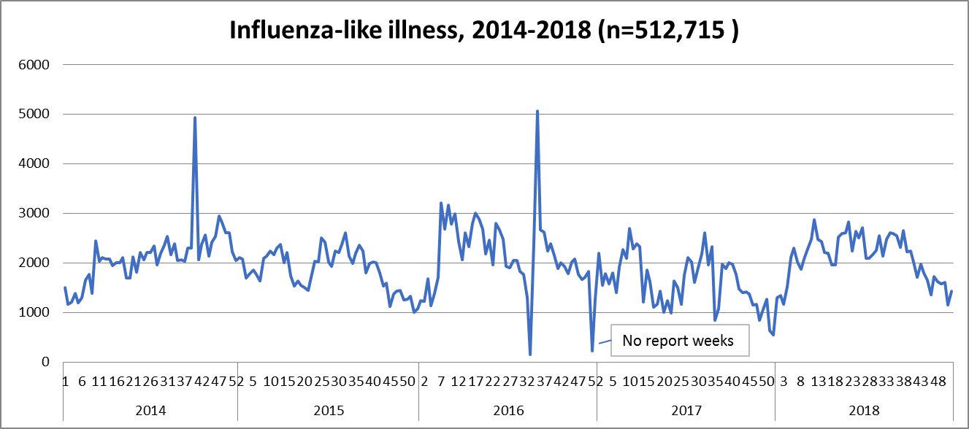
Lab-confirmed Influenza
Lab-confirmed Influenza

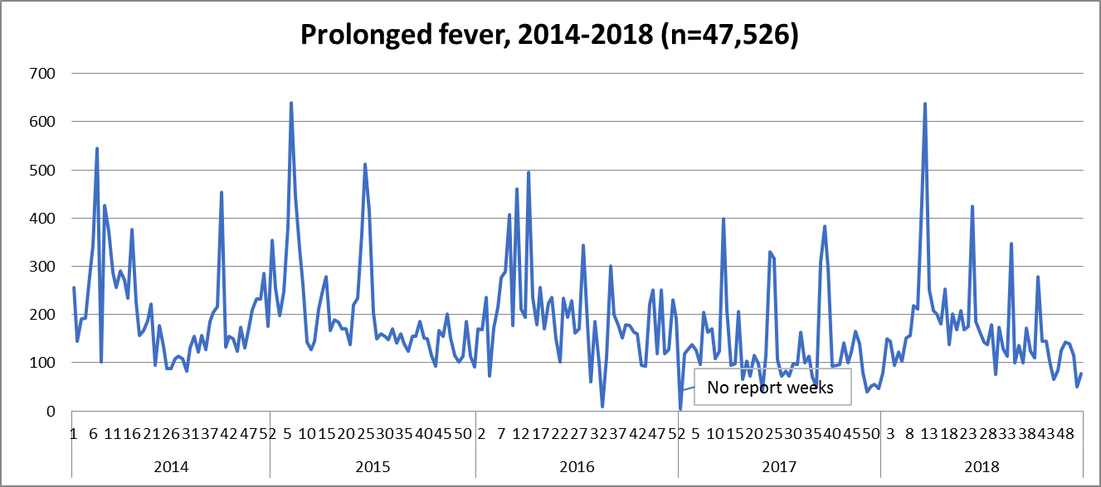
Leptospirosis
Leptospirosis

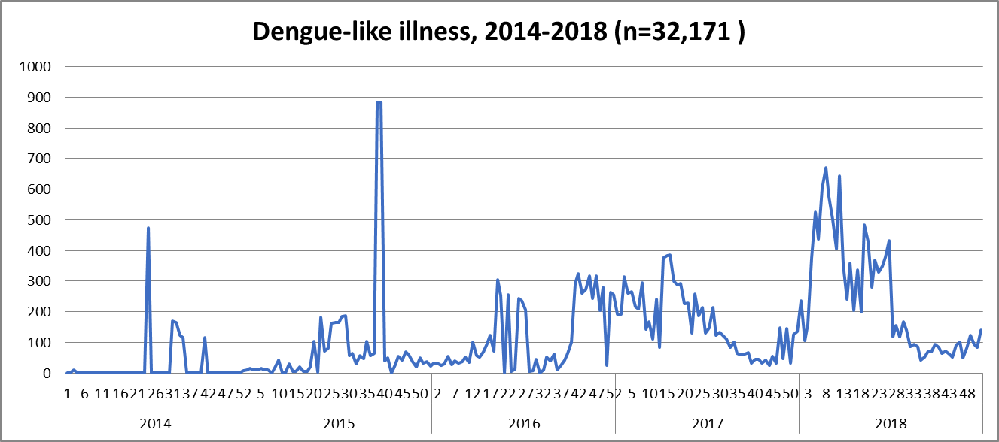
Dengue, chikungunya and Zika virus
Dengue
Dengue
Dengue
Only 16 PICTs use the dengue-like illness indicator currently. There has been an increase in use of this syndrome since 2015
Annex 2. Assessment Rating on LQMS (WHO Minimum Standards) and SLIPTA (ISO 15189 standards), 2015-2019
Laboratory Facility / PICT Name | WHO Minimum Standards | Full ISO 15189 / SLIPTA
TONGA VCH | 100% | 97% (2018)
TONGA Provincial Laboratories
Eua, Vavau, Ha”apai | 80%, 78%, 62%
FIJI CWM | 88% (2017)
FIJI Provincial Laboratories | >90% Collective score
Labasa | 94% in 2017
Savusavu | 95% in 2017
Seaqaga | 93% in 2017
Nabouwalu | 92% in 2017
Taveuni | 90% in 2017
FIJI Mataika House | 95% in 2018 | 45% (2018)
FIJI Private Laboratories | >90% Collective score
SAMOA TTM |  | 84.5% (2018)
SAMOA Provincial Laboratories | 82% in 2019
VANUATU VCH |  | 89% (2018)
VANUATU Provincial Laboratories | 69% in 2019
TIMOR LISTE - NHL & HNGV | 45% in 2018 | >40% in 2019
SOLOMONS NRH |  | 60% (2018)
SOLOMONS Provincial Lab (Gizo) | 40%
KIRIBATI TCH | 60% in 2017
NAURU RONH |  | 76% (2017)
COOK ISLANDS RH |  | 74% (2015)
Laboratory Facility / PICT Name | WHO Minimum Standards | ISO 15189/ SLIPTA
TUVALU PMH | 50% | 47% (2017)
MARSHALL ISLANDS MCH | 60% | 33% (2015)
EBEYE | 60% | 35% (2015)
POHNPEI | 36% 2017
YAP | 60% 2018

Annex 3. Laboratory Mentorship Schedule, 2019-2020

Level 2 Reference Laboratory (Mentor) | Target PICT (2019) | Target PICT (2020)
Guam Public Health Laboratory | Palau | Yap, FSM  RMI
Mataika House Laboratory, Fiji | Kiribati | Tuvalu
Institut Pasteur New Caledonie | Vanuatu;  Solomon Islands  Samoa | Fiji
Institut Louise Malarde, French Polynesia | Cook Islands  Nauru | Niue

Annex 4. Schedule of SPC support package for Infection prevention and control and AMR

Activity | 2019 | 2020 | 2021
Updating of infection control guideline | Cook Islands, Kiribati, Samoa, Solomon Islands | FSM – (Chuuk, Kosrae, Pohnpei), Tonga | Solomon Islands  Vanuatu  Niue  Guam
AMR and microbiology training | Cook Islands, Fiji, Kiribati, Nauru, RMI, Samoa | FSM – (Chuuk, Kosrae, Pohnpei), Tonga | Solomon Islands  Vanuatu  Niue  Guam

Annex 5. Schedule of SHIP-DDM Activities, 2019-2021

Pacific Community (SPC) | 2019 |  | Conduct PGCFE course sub-regional cohort  Fiji, Tokelau, Tonga, Solomon Island, Tuvalu | Develop training manual for trainers and manual for trainees
Pacific Community (SPC) |  |  | Consultation meeting in country for National PGCFE course project  Fiji, Kiribati, Cook Island, Nauru, Niue, Samoa, Tonga | Conduct National PGCFE courses (Module 1-5)  Fiji, Kiribati, Cook Island, Nauru, Niue, Samoa, Tonga |  | French translation of training materials to enable delivery in Francophone countries
Pacific Community (SPC) | 2020 |  |  | Conduct Training of trainers and mentors |  | Work on accreditation with French university
Pacific Community (SPC) |  |  | Conduct PGDAE course: Operational Research | Conduct National PGCFE courses in French (Mod 1-5) |  | Work on accreditation with French university
Pacific Community (SPC) | 2021 |  | Conduct PGDAE course: Operational Research | French Polynesia, New Caledonia, Wallis and Fortuna
PIHOA / CDC | 2019 |  | Conduct PGCFE National courses (Modules 1 - 5)  RMI, Palau, CNMI | Conduct National PGDAE courses: Op. Research  Guam, American Samoa, FSM
PIHOA / CDC | 2020 |  | Conduct National PGDAE courses: Operational Research  RMI, Palau, CNMI | Conduct National MAE course (Masters)  Guam, American Samoa, FSM |  | Conduct PGCFE National courses (Modules 1 - 5)  Guam, American Samoa, FSM (new cohort)
PIHOA / CDC | 2021 |  | Conduct National MAE course (Masters)  RMI, Palau,CNMI | Conduct National PGDAE courses: Operational Research  Chuuk, Kosrae,Yap
Legend:
GREEN: Implementation on-going
YELLOW: Preparatory work in progress
BLUE: To be started

SHIP is a 3-level programme. First tier is the Postgraduate Certificate in Field Epidemiology (PGCFE). Second tier is the Postgraduate Diploma in Applied Epidemiology (PGDAE). Third tier is Master in Applied Epidemiology (MAE). The 3-level SHIP programme comes with academic accreditation with FNU.
Only 14 PICTs are currently using the dengue-like illness indicator; hence the relatively low number of notifications.
Guam Public Health Laboratory, Institut Louis Malarde in French Polynesia, Institut Pasteur de Nouvelle-Caledonie, and Mataika House Laboratory in Fiji Ministry of Health and Medical Services
Excepting FSM, each PICT has an EpiNet team. FSM has 5 EpiNet teams: 1 national team and 1 team for each of the 4 states
Data management ; clinical medicine ; laboratory service ; field investigation; public health management
Vanuatu, Tonga and Tokelau
Postgraduate Certificate in Field Epidemiology has 5 modules: Introduction to Epidemiology and Field Epidemiology; Public Health Surveillance; Outbreak Investigation and Management; Computing for Public Health Practice; Field Epidemiology Project
Fiji, Nauru, Niue, Samoa, Kiribati, Solomon Islands, Tonga

